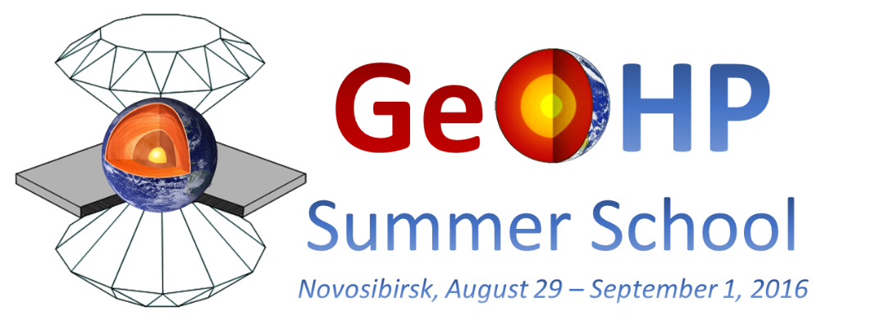
Dear Colleagues,
We are pleasured to announce the schedule of the forthcoming GeoHP-2016 Summer School "High-pressure techniques for petrology and geodynamics of Earth and planetary interiors" to be held in Sobolev Institute of Geology and Mineralogy (Novosibirsk, Russia) from August 29th to September 1st, 2016.
AUGUST 29:
- 15.00-15.45: Hiroyuki KAGI (University of Tokyo, Japan) The enigma of carbonado petrogenesis: crustal, mantle, or impact origin and problem of the source materials
- 15.45-16.30: Toru INOUE (Ehime University, Japan) Water in the mantle: high pressure hydrous phases and nominally anhydrous minerals
- 15.30-17.00: Coffee Break
- 17.00-17.45: Hiroaki OHFUJI (Ehime University, Japan) Experimental study on the graphite-diamond transformation and its implication for the formation mechanism of natural impact diamonds
- 17.45-18.30: Junji YAMAMOTO (Hokkaido University, Japan) Fluid inclusions: a probe for depth origin of mantle minerals
AUGUST 30:
- 17.00-17.45: Eiji OHTANI (Tohoku University, Japan) Phase relations and physical properties of the iron-light element compounds at high pressure and temperature, and the chemical structure of the inner core
- 17.45-18.30: Tatsuki TSUJIMORI (University of Tokyo, Japan) Recycling of crustal materials through study of ultrahigh-pressure minerals in collisional orogens, ophiolites, and mantle xenoliths
AUGUST 31:
- 09.30-10.15: Inna SAFONOVA (Sobolev Institute of Geology and Mineralogy, Russia) Generation of hydrous-carbonated plumes in the mantle transition zone linked to tectonic erosion and subduction
- 10.15-11.00: Talgat INERBAEV (Gumilyov Eurasian National University, Kazakhstan) Ab initio methods in high-pressure crystallography
- 11.00-11.30: Coffee Break
- 11.30-12.15: Konstantin LITASOV (Sobolev Institute of Geology and Mineralogy, Russia) Carbon-bearing magmas and material transport in the deep Earth's mantle
- 12.15-13.00: Anton SHATSKIY (Sobolev Institute of Geology and Mineralogy, Russia) Phase relations in carbonate-silicate systems at 6 GPa
- 13.00-15.00: Lunch
- 15.00-15.45: Sergey LOBANOV (Carnegie Geophysical Laboratory, USA) Probing spin transitions in mantle minerals by optical spectroscopy
- 15.45-16.30: Sergey RASHCHENKO (Novosibirsk State University, Russia) High-pressure + high-temperature techniques in diamond anvil cell
SEPTEMBER 1:
- 09.30-10.15: Konstantin KOKH (Novosibirsk State University, Russia) Cleavage in technical crystals: benefits and losses
- 10.15-11.00: Anna DYMSHITS (Sobolev Institute of Geology and Mineralogy, Russia) Use of equations of state and equation of state software packages
- 11.00-11.30: Coffee Break
- 11.30-12.15: Igor SHARYGIN (Sobolev Institute of Geology and Mineralogy, Russia) Kimberlite magma composition in mantle source region: constrains from melting phase relations
- 12.15-13.00: Taisia ALIFIROVA (Sobolev Institute of Geology and Mineralogy, Russia) Exsolution lamellae in rock-forming minerals in the mantle xenoliths from Siberian craton
- 13.00-15.00: Lunch
- 15.00-15.45: Anastasia MIKHNO (Sobolev Institute of Geology and Mineralogy, Russia) Fluid and melt inclusions from the UHPM rocks: Raman spectroscopic approach
- 15.45-16.30: Andrey KORSAKOV (Sobolev Institute of Geology and Mineralogy, Russia) Grain-scale pressure variations: Is it possible to create UHPM conditions in the Earth's crust?

All lectures will be held in the Main Conference Hall of the Institute (3 Koptyug Avenue):
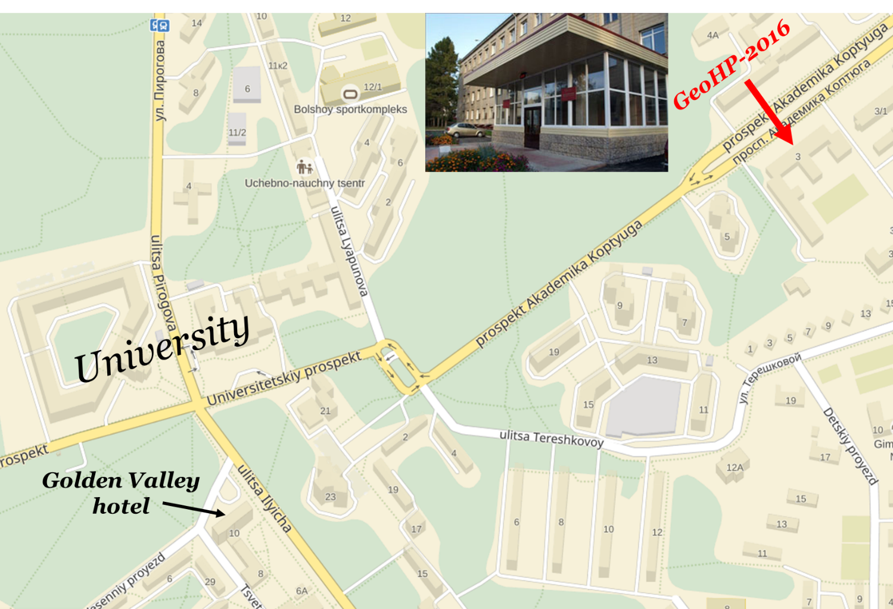
The School is free of charge, but travel and accommodation expenses are carried by participants. In case of any questions, please contact the School principal organizer Prof. Andrey KORSAKOV (akorsakov74@gmail.com).
Sincerely,
Organizers

